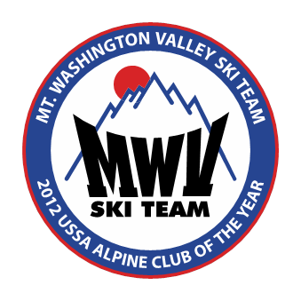

Winter 2017

Competitors, Coaches, and Families;

Welcome to the USSA Eastern Regional High School Championship!

March 10-12, 2017

The event is hosted by the Mount Washington Valley Ski Team, at the Attitash Ski Resort, in Bartlett, NH.

This Championship allows high school teams representing all states within the Eastern region, plus out of region guest teams, to compete against other state teams. This particular competition is open to all members of a state high school team who have qualified through state selection procedures. Team quota (state) is limited to twelve girls and twelve boys.

Our organization is excited to be hosting this event once again, and look forward to helping you truly enjoy your visit to Attitash and the surrounding Mount Washington Valley area.

We are very appreciative of our 2017 Event Sponsor Northway Bank

Welcome, Congratulations, and Good Luck!

The Staff & Board of Directors,
Mount Washington Valley Ski Team

All racers must be USSA members, or purchase a short term membership to participate in this event; A Form has been included in this package for convenience, but should be completed prior to the event. This is a USSA event so FIS legal helmets must be used for the GS.

The event will begin with a Training day at Bear Peak on Friday. Racers may register from 8am until 4pm, at the Bear Peak Base Lodge. Team Captain’s Meeting will be at 4pm at the Hotel.

Saturday’s Giant Slalom race will be on the Illusion trail. Bibs will be issued at the Bear Peak Base Lodge, beginning at 7:30am. Bibs must be returned at the end of the race and will be re-issued on Sunday. Team Captain’s Meeting will be at 4pm at the Hotel (If Necessary).

The Saturday Night Banquet will be held in the Attitash Grand Summit Hotel Ballroom. The banquet begins at 6:30 pm. Giant Slalom awards will be presented at the banquet, and team standings will be announced, there will also be an athlete bib number raffle. Registered athletes and up to three official USSA coaches per team receive dinner tickets as part of the event. Additional tickets are available please let us know estimated numbers when registering your team.

Sunday’s Slalom will also be on the Illusion trial. Bibs will be reissued at the Bear Peak Base Lodge. At the conclusion of the race Slalom, combined, and team awards will be presented there.

At the end of Sunday’s race, this year it is NOT anticipated that the b-netting will need to be taken down, rolled, and left standing off to the side of the trail. If this is required, it is expected that all athletes and coaches will assist with this, and awards will take place after all of the netting has been stored.

The entry fee for the three day event is $195.00 per racer. This includes 3 days of lift tickets, the banquet on Saturday night, and a commemorative racer bib. For the Saturday night banquet extra coach tickets are $25 each, and parent and guest tickets are $25 each. Please let us know how many coach and family tickets you will need when you submit your team roster, so we can plan on enough food. There will be a limited number of tickets available at registration. Each Team will be allotted up to three complementary coaches lift tickets, Names & Valid USSA # must be submitted in advance to martha@mwvskiteam.com

Checks should be payable to MWVST. We are not able to take credit cards.

Friday tickets are available for $40.00 (subject to change) , but must be purchased in advance, online. Check www.attitash.com or liftopia.com for details, and to purchase.

Tickets for Extra Coaches, Parent, & Sibling ski tickets will be available at registration for cash only for a $55.00 ticket Friday (if not purchased inadvance), Saturday, and Sunday, and are valid for all skiing at the Attitash Resort. Our resort has two separate base areas that have connecting ski trails, and also connected via free shuttle bus.

Technical long sleeve wicking shirt and Sweatshirts will be available for purchase in advance at the following Link http://www.hurricaneracing.com/store/categories/Eastern-HS-Alpine-Championships/; Keep an eye out design will be completed shortly. Ordering Deadline will be Monday at 2pm, March 6th.

Congratulations on your qualification for this event, we hope you enjoy skiing, racing, and visiting our area. If you need more information or have any questions please ask.

Mount Washington Valley Ski Team, PO Box 780 Intervale, NH 03845
martha@mwvskiteam.com www.mwvskiteam.com 603-356-762

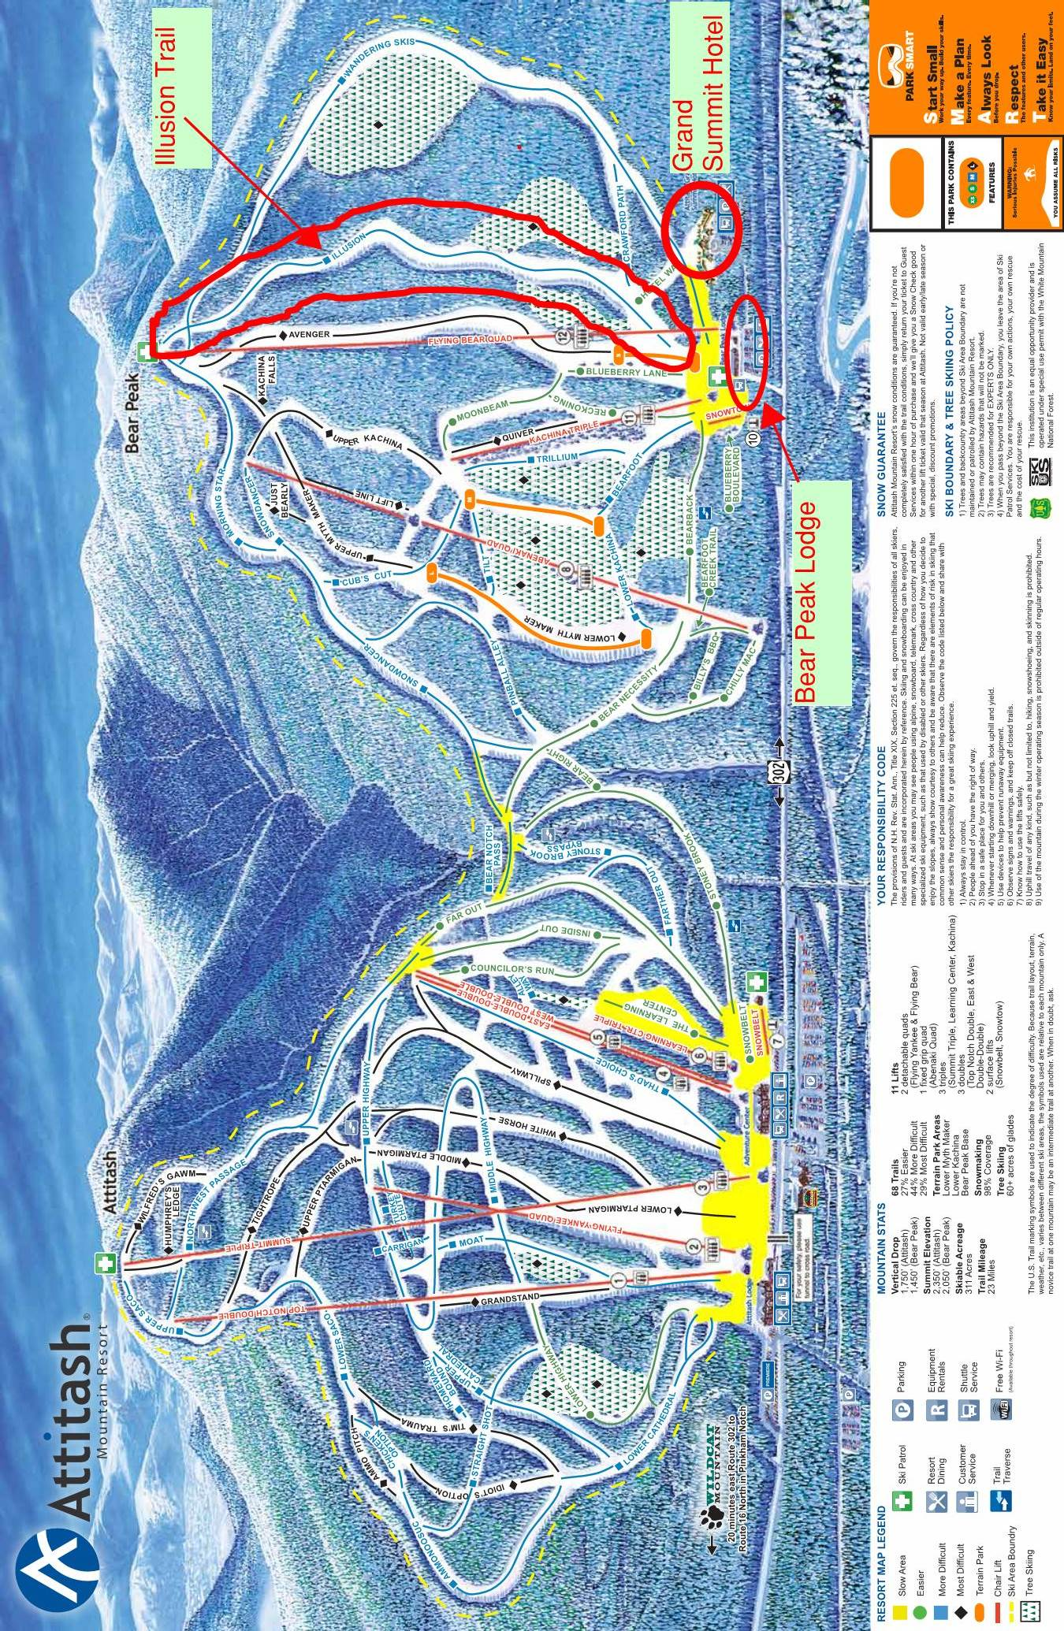

DIRECTIONS
Attitash Mountain Resort is located on Route 302 in Bartlett, NH. The entrance to Bear Peak is located about ½ mile west of the Attitash main base area on Route 302. The Team Captain’s Meeting will be at 4pm on Friday, at the Attitash Grand Summit Hotel.
DINING

Teams are on their own for dinner on Friday night. http://www.mtwashingtonvalley.org/ is the web site for our local Chamber of Commerce.

The Valley Originals are a group of locally owned and operated restaurants, of all types, located in the valley. Visit their website at, www.thevalleyoriginals.com,to find a complete list of these restaurants and information about each one.

Some additional food options that are very close to the event are; Matty B’s is a pizza place located at Attitash Mt. Village, across from the Attitash base area. Bart’s Deli and Store is located just west of Bear Peak. Patches Deli and Store is about 2 miles east of Attitash. The closest supermarket is Grant’s Shop’ N Save in Glen east of Attitash on Route 302.

LODGING

In the past many teams have stayed at the Attitash Grand Summit Hotel which is ski in- ski out to the event, or Attitash Mountain Village which is across the street from Attitash.

The closest lodging to the event is The Attitash Grand Summit Hotel which is slope side at Bear Peak where the races will be held. 603-374-1900, or go to www.Attitash.com, and click on lodging options.
The hotel currently has availability for the EHSC in March and has discounted rates for Ski Groups/Schools. The hotel would provide easy access to racers. Group contact listed below.
Guest Services Director Attitash Grand Summit Hotel
603-374-2174 or 888-554-1900 Ext 2174
The Attitash Mountain Village Condominiums are located about ½ mile away, across the road from the Attitash main base area.

The Attitash Marketplace Motel is ½ mile east of Attitash on route 302 is another option, and has pet friendly rooms.

Both these options can be contacted at1-800-862-1600, 603-374-6500, or www.attitashmtvillage.com

There are many places to stay in the Mount Washington Valley Area
The MWV Chamber of Commerce can be contacted at 603-356-5701,
www. mtwashingtonvalley.org, or 1-800-367-3364

There are many places in the valley listed on the VRBO and similar websites.

North Conway Village is about 10 miles from Attitash on Route 302.

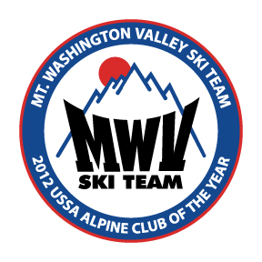
2017 USSA EASTERN HIGH SCHOOL
ALPINE CHAMPHIONSHIPS

Tentative EVENT SCHEDULE
FRIDAY, MARCH 10TH | TRAINING DAY
LIFTS OPEN FOR GATE TRAINING. 2 split GS training course will be provided in the morning and afternoon.  (States must provide their own training gates and equipment for SL, hill space and GS/SL matrix will be assigned) | 9:00 AM
REGISTRATION  (Bear Peak Base Lodge) | 8:00 AM – 3:00 PM
CAPTAINS MEETING  (Grand Summit Hotel-Second run Course setter(s) and referees will be selected for the GS & SL.) | 4:00 PM
SATURDAY, MARCH 11TH | GIANT SLALOM
COURSE SETTERS LOAD LIFT (quad) | 7:15 AM
RACE REGISTRATION (Bear Peak Base Lodge) | 7:30 AM
COURSE OPEN FOR INSPECTION | 8:30 AM
GIRLS 1ST RUN BEGINS | 9:30 AM
BOYS 1ST RUN BEGINS | Completion of Girls 1st run
2ND RUN SET | Completion of Boy’s 1st run
GIRLS 2ND RUN BEGINS | 12:30 PM
BOYS 2ND RUN BEGINS | Completion of Girls 2nd run
CAPTAINS MEETING Grand summit Hotel | 4:00 PM (If Necessary)
BANQUET  Dinner & Awards at the Grand Summit Hotel | 6:30 PM
SUNDAY, MARCH 12TH | SLALOM
COURSE SETTERS LOAD LIFT | 7:00 AM
RACE REGISTRATION | 7:30 AM
COURSE OPEN FOR INSPECTION | 8:30 AM
GIRLS 1ST RUN BEGINS | 9:30 AM
BOYS 1ST RUN BEGINS | Completion of Girls 1st run
GIRLS 2ND RUN SET | Completion of Girls 1st run
BOYS 2ND RUN SET | Completion of Boys 1st run
GIRLS 2ND RUN BEGINS | 12:30 PM
BOYS 2ND RUN BEGINS | Completion of Girls 2nd run
AWARDS (Bear Peak Base Lodge after netting work) | 4:00 PM

2017 USSA EASTERN HIGH SCHOOL
ALPINE CHAMPHIONSHIPS

DINNER & AWARDS BANQUET

The Dinner & Awards Banquet will take place on Saturday, March 11th at 6:30 PM at the Attitash Grand Summit Hotel at Bear Peak in Bartlett, NH.

Directions:

The Grand Summit Hotel is located adjacent to the Bear Peak base area.

Take Rte 16 North; at the intersection of Rte 16 & Rte 302, go straight on Rte 302 toward Bartlett.

You will pass Attitash base area on the left, the entrance to Bear Peak and the Grand Summit is about 1/2 mile past Attitash, also on the left. Turn into the entrance; follow the signs to the Grand Summit Hotel.

Athletes will check in by bib number.

Additional tickets $25 please purchase on Friday, if possible, please let us know in advance.

Bib Raffle after dinner, must be present to win.

2017 USSA EASTERN HIGH SCHOOL
ALPINE CHAMPHIONSHIPS

EVENT ENTRY LIST
(DEADLINE Monday, March 6th)

SLALOM STATE_____________________

Return entry to Kathy Badger-badger5@roadrunner.com, 38 East Shore Drive Silver Lake, NH 03875

Running Order  GIRLS | NAME | USSA #
1
2
3
4
5
6
7
8
9
10
11
12
Running Order  BOYS | NAME | USSA #
1
2
3
4
5
6
7
8
9
10
11
12

2017 USSA EASTERN HIGH SCHOOL
ALPINE CHAMPHIONSHIPS

EVENT ENTRY LIST
(DEADLINE Monday, March 6th)
GIANT SLALOM STATE_____________________

Return entry to Kathy Badger-badger5@roadrunner.com, 38 East Shore Drive Silver Lake, NH 03875

Running Order  GIRLS | NAME | USSA #
1
2
3
4
5
6
7
8
9
10
11
12
Running Order  BOYS | NAME | USSA #
1
2
3
4
5
6
7
8
9
10
11
12

2017 USSA EASTERN HIGH SCHOOL
ALPINE CHAMPHIONSHIPS

COACHES EVENT ENTRY LIST

State __________________

 | Name | USSA#

1

2

3

4

5

6

7

8

