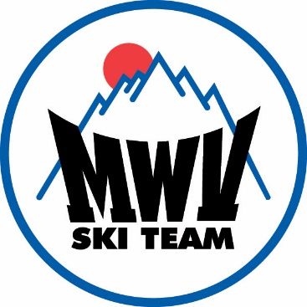
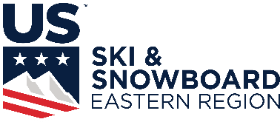
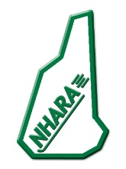

Welcome to the 2022 USSS Eastern High School Championships!
March 3-6, 2022
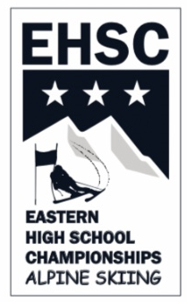

This event is hosted by the Mount Washington Valley Ski Team, at the Attitash Ski Resort, in Bartlett, NH. The event allows high school teams representing all states within the Eastern region, plus out of region guest teams, to compete against other state teams. This particular competition is open to all members of a state high school team who have qualified through state selection procedures. Team quota (state) is limited to twelve girls and twelve boys.

Our organization is excited to be hosting this event once again, and look forward to helping you truly enjoy your visit to Attitash and the surrounding Mount Washington Valley area.

Welcome, Congratulations, and Good Luck!

The Staff & Board of Directors,
Mount Washington Valley Ski Team/ mwvskiteam.com/ info@mwvskiteam.com

All racers must be USSS members, or purchase a short term membership to participate in this event, this should be completed prior to the event. Athletes without a USSS competitors license may want to get the non-scored competitors membership for $100.00. Do USSS memberships as soon as possible!
This is a USSS event so FIS legal helmets must be used for the GS, and all skis must USSS compliant in order to race. All coaches must be current USSS coaches to be given tickets and allowed on the hill.

The event will begin with a Training day at Bear Peak on Thursday. Lifts open at 9am. Racers may be registered from 8am until 4pm, at the Bear Peak Base Lodge. Due to COVID coaches should collect monies and register and pay for their teams. (multiple checks and cash are fine) Team Captain’s Meeting will be at 4pm location is TBD.

Friday’s Men’s/Women’s Slalom race will be on the Illusion trail. Bibs will be issued at the Bear Peak Base Lodge, beginning at 7:30am. Race Start Time is 9:30am. Team Bibs and Tickets will be issued to coaches The Bib will be your number for the duration of the event. Team Captain’s Meeting will be at 4pm. (If Necessary). Awards will be presented after the race on the Bear Peak Base Lodge Deck.

Saturday’s Women’s Giant Slalom and Sunday’s Men’s Giant Slalom, will be held on the Illusion trail. Coaches will pick up team tickets at Registration. Non racing athletes will pick up tickets at Registration. Race Start Time is 9:30am. Following the conclusion of the races, race awards and overall awards will be presented on the Bear Peak Base Lodge Deck.

At the end of Sunday’s race, b-netting work will need to be done. It is expected that all athletes and coaches will assist with this, and awards will take place after all needed netting work has been completed.

The entry fee for the three day event is $245.00 per racer, this includes 3 days of lift tickets (Fri, Sat, and Sun), and a commemorative T-shirt. The Training Day on Thursday is $50
The entry fees for EPIC pass holders will be $180 per racer, $20 for the Training Day, these athletes will not be given lift tickets.
Checks should be payable to MWVST. We are not able to take credit cards.

Lift tickets for Extra Coaches, Parent, & Siblings will be available at registration each day, cash/check only, for $TBD.

Event Hooded Sweatshirts will be available for purchase in advance at the following Link: TBD Keep an eye out the design will be completed shortly. Ordering Deadline will be TBD; if you want to have the items in time for delivery at the event. Post Deadline Orders will remain available/open until TBD for a second printing run, with delivery in the first week of April, with an additional shipping charge of $7.50/Item. Updated information will be sent when available.

Congratulations on your qualification for this event, we hope you enjoy skiing, racing, and visiting our area. If you need more information or have any questions please ask, we can supply a lot of local information.

Mount Washington Valley Ski Team, PO Box 780 Intervale, NH 03845
martha@mwvskiteam.com www.mwvskiteam.com 603-662-6420

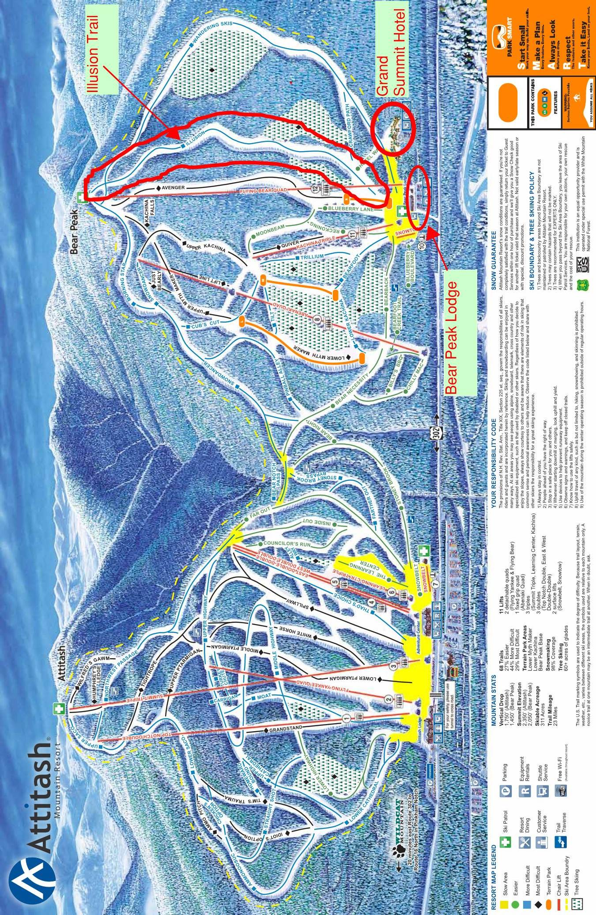

DIRECTIONS
Attitash Mountain Resort is located on Route 302 in Bartlett, NH. The entrance to Bear Peak is located about ½ mile west of the Attitash main base area on Route 302. The Team Captain’s Meeting will be at 4pm on Thursday, at the Grand Summit at Attitash Hotel.
DINING

Due to the pandemic teams are on their own for dinners. http://www.mtwashingtonvalley.org/ is the web site for our local Chamber of Commerce.

The Valley Originals are a group of locally owned and operated restaurants, of all types, located in the valley. Visit their website at, www.thevalleyoriginals.com, to find a complete list of these restaurants and information about each one.

Some additional food options that are very close to the event are; Matty B’s is a pizza place located at Attitash Mt. Village, across from the Attitash base area. Bart’s Deli and Store is located just west of Bear Peak. Patches Deli and Store is about 2 miles east of Attitash. The closest supermarket is Grant’s Shop’ N Save in Glen east of Attitash on Route 302.

LODGING

In the past many teams have stayed at the Grand Summit at Attitash, which is ski in- ski out to the event, or Attitash Mountain Village which is across the street from Attitash.

The closest lodging to the event is The Grand Summit at Attitash which is slope side at Bear Peak where the races will be held. 603-374-1900, or go to www.Attitash.com, and click on lodging options.
The hotel currently has availability for the EHSC in March and has discounted rates for Ski Groups/Schools. The hotel would provide easy access to racers. Group contact listed below.
Guest Services Director Grand Summit at Attitash
603-374-2174 or 888-554-1900 Ext 2174
The Attitash Mountain Village Condominiums are located about ½ mile away, across the road from the Attitash main base area.

The Attitash Marketplace Motel is ½ mile east of Attitash on route 302 is another option, and has pet friendly rooms.

Both these options can be contacted at1-800-862-1600, 603-374-6500, or www.attitashmtvillage.com

There are many places to stay in the Mount Washington Valley Area
The MWV Chamber of Commerce can be contacted at 603-356-5701,
www. mtwashingtonvalley.org, or 1-800-367-3364

There are also many places in the valley listed on the AirBnB and VRBO websites.

North Conway Village is about 10 miles from Attitash on Route 302.

2022 USSS EASTERN HIGH SCHOOL
CHAMPHIONSHIPS
EVENT SCHEDULE

THURSDAY, MARCH 3 TRAINING DAY

LIFTS OPEN FOR GATE TRAINING. 9:00 AM

REGISTRATION (Bear Peak Base Lodge) 8:00 AM – 4:00 PM

CAPTAINS MEETING Course setter(s) and referees will be selected for the SL & GS.) 4:00 PM

FRIDAY, MARCH 4 SLALOM

COURSE SETTERS LOAD LIFT 7:00 AM

RACE REGISTRATION 7:30 AM

COURSE OPEN FOR INSPECTION 8:30 AM

GIRLS 1ST RUN BEGINS 9:30 AM

BOYS 1ST RUN BEGINS Completion of Girls 1st run

GIRLS 2ND RUN SET Completion of Girls 1st run

BOYS 2ND RUN SET Completion of Boys 1st run

GIRLS 2ND RUN BEGINS 12:30 PM

BOYS 2ND RUN BEGINS Completion of Girls 2nd run

SATURDAY and SUNDAY, MARCH 9 and 10 GIANT SLALOM

COURSE SETTERS LOAD LIFT (quad) 7:15 AM

RACE REGISTRATION (Bear Peak Base Lodge) 7:30 AM

LIFTS & COURSE OPEN FOR INSPECTION 8:30 AM

1ST RUN BEGINS 9:30 AM

2ND RUN SET Completion of 1st run

2ND RUN BEGINS 12:30 PM

